ICC Assignment 1 | Laiba Fatima 22K-5195 | BSE-7B
Project: Personal Finance Tracker | Project Code: F
Step 1
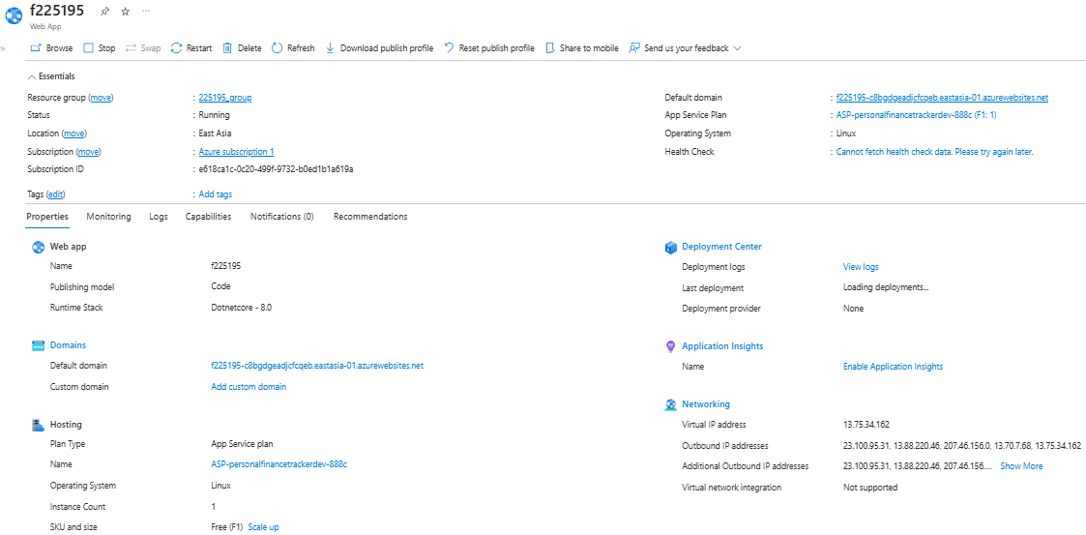I chose .NET 8 (LTS) as the runtime stack for this web app because it’s the latest. It means I’ll benefit from long-term stability, regular security updates, and ongoing performance improvements, which means they are important to keep a reliable and efficient web app . Moreover, .NET 8 offers better performance and cross-platform support than previous versions, which makes it a great fit for running on a Linux-based Azure App Service. To keep things cost-effective, I went with the Free (F1) pricing tier. It includes 1 GB of memory and shared CPU resources, which are more than enough for a small student project. While the free tier comes with some limitations, like no custom domains or autoscaling, it works perfectly for development, testing, and showcasing the app without any financial burden. For the region, I selected East Asia because it’s closer to where I’m located and this is what sir Sudais said to choose in class. This helps reduce latency and improves the overall speed and responsiveness when working with the app during development and testing. Plus, Azure has reliable data centers in that region, so deploying the app there ensures better performance for nearby users.
Step 2 App’s Functionality:
MoneyTalks is a personal finance tracker designed to help users take control of their money and build healthier financial habits. They can easily log their daily income and expenses, organize transactions into categories, and get insights into their spending patterns. The app lets the user set their monthly budgets for different categories and it tracks how well the user is sticking to their budgets with the help of analytic charts (pie,bar graph). Users can clearly see where they might be overspending. MoneyTalks will let users set goals and reminders, and provide detailed reports that will show the overall spending trends. The app is built using Azure Functions to automatically process and categorize transactions. The data is securely stored in Azure Cosmos DB, while receipts and other documents are safely saved using Azure Blob Storage. Azure API Management ensures secure and reliable communication between the front-end and back-end services, and the whole application is hosted on Azure App Service for fast and reliable service. MoneyTalks is built with ASP.NET Core MVC and it offers a clean, user-friendly interface. MoneyTalks helps users to stay organized and make better money decisions.
Step 3
Live URL: https://f225195-c8bgdgeadjcfcqeb.eastasia-01.azurewebsites.net/
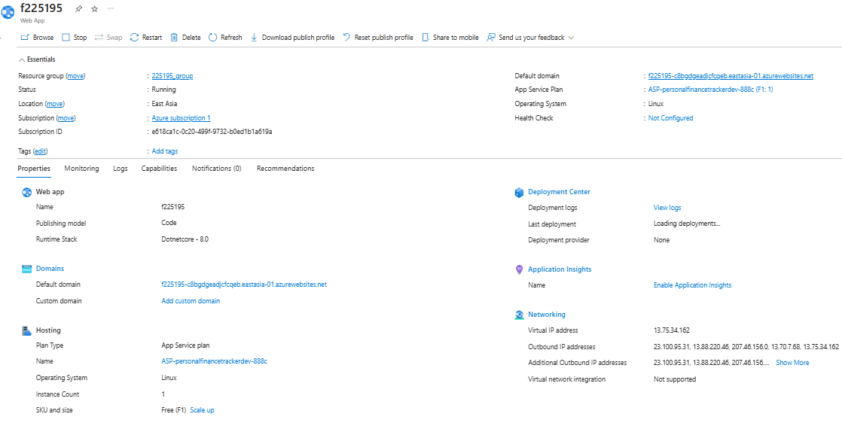
Challenges:
When I was deploying MoneyTalks, my Azure tools workload was not installed in Visual Studio so I had to install that which took a lot of time because then I had to update my Visual Studio, then I had to sign in again to my Azure account in visual studio. The other issue was during deployment I selected AppService (windows) so i couldn't see any existing app service on it. But then I went back and selected App service for Linux, and my existing app service f225195 was present there. Apart from this, the deployment was smooth as I followed online resources for guidance
